Annex No11.
to the decision of the Board of Directors
of Otbasy Bank JSC
(Minutes of the meeting #10 dated June 25, 2025)

 | Superior internal document | Development Strategy of JSC Otbasy Bank for 2024-2033
 | Owner of the internal document | Planning and Strategic Analysis Department
 | Developed | Adilbekova K.K. - Acting Director of Planning and Strategic Analysis Department  Temesheva A.S. - Head of Sustainable Development Division of Planning and Strategic Analysis Department
 | Approved | By the decision of the Board of Directors of Otbasy Bank JSC (Minutes of the meeting #10 dated June 25, 2025).
 | Effective date | June 25, 2025
 | Restriction Grif

STRATEGY OF SUSTAINABLE DEVELOPMENT
OF OTBASY BANK JSC UNTIL 2030

Almaty, 2025

CONTENTS

Chapter 1. INTRODUCTION 3
Chapter 2: THE BANK'S MISSION IN THE CONTEXT OF SUSTAINABLE DEVELOPMENT 3
Chapter 3: FOCUS OBJECTIVES OF UN SUSTAINABLE DEVELOPMENT 3
IN THE CONTEXT OF THE BANK'S STRATEGY 3
Chapter 4. PRIORITY AREAS FOR ACTION AND RELATED GOALS 5
Chapter 5. ESG-RISK MANAGEMENT 7
Paragraph 1: ECOLOGICAL RISKS 8
Paragraph 2: SOCIAL RISKS 8
Paragraph 3. CORPORATE RISKS 9
Chapter 6. ESG-KPD (KEY PERFORMANCE INDICATORS) 10

Chapter 1. INTRODUCTION
- Otbasy Bank JSC (hereinafter - the Bank, Otbasy Bank JSC) is a national development institution that plays a key role in the formation of a sustainable financial system focused on the long-term interests of citizens and the state. And also the Bank is the only participant of the housing construction savings system in Kazakhstan and serves millions of customers throughout the country, including socially vulnerable groups, and acts as a driver of improving the quality of life of the population through access to decent and sustainable housing.
- The Sustainable Development Strategy of Otbasy Bank JSC until 2030 (hereinafter - the Sustainable Development Strategy) is aimed at integrating ESG (Environmental, Social, Governance) principles into the Bank's operations, contributing to the achievement of the United Nations (hereinafter - UN) Sustainable Development Goals (hereinafter - SDGs) and the socio-economic progress of Kazakhstan. The Bank plans to continue to develop initiatives in the areas of affordable housing, environmental sustainability and corporate responsibility, providing long-term value to society and the country's economy.
- This Sustainable Development Strategy defines the mission, main goals and priority areas of the Bank's sustainable development, as well as key performance indicators until SUB 2030 in the field of sustainable development.

Chapter 2: THE BANK'S MISSION IN THE CONTEXT OF SUSTAINABLE DEVELOPMENT
- According to the Bank's 2024-2033 Development Strategy, Otbasa Bank's mission is to strengthen the sense of homeland by providing families with their own homes, enhancing long-term well-being. The realization of this mission directly contributes to the achievement of the UN SDGs.
- Sustainable development for the Bank is not just a trend, but an integral part of its corporate philosophy. This is expressed in the integration of socially oriented and environmentally responsible solutions into every business function - from product development to internal culture and external reporting.
- Thus, the Bank strives to be not just a financial organization, but an institutional leader in building a fair, sustainable and inclusive future for Kazakhstan's society.
- The implementation of the Sustainability Strategy allows the Bank to realize the principles of sustainability and responsibility in a systematic and transparent manner.
- For the Bank, the Sustainable Development Strategy means:
- reduction of reputational and investment risks;
- increased transparency and trust on the part of international partners and investors;
- resilience to challenges related to climate change, social instability and changes in the regulatory framework;
- strengthening its position as one of the leaders of the ESG movement in Kazakhstan.
- For the Bank's clients, the ESG approach means:
- improving the quality of services and products offered, taking into account the needs of various social groups, including young people, large families and women;
- development of initiatives aimed at energy efficiency of housing and reduction of utility costs;
- raising public awareness of the opportunities for sustainable lifestyles and smart consumption.
- The implementation of the Sustainable Development Strategy is a step towards creating a more sustainable and just society in which every citizen receives not only financial support, but also a sense of confidence in the future. It is a philosophy of responsibility that the Bank shares with its customers and partners, striving for harmony between economic growth, social justice and environmental protection.

Chapter 3: FOCUS OBJECTIVES OF UN SUSTAINABLE DEVELOPMENT

IN THE CONTEXT OF THE BANK'S STRATEGY
- Otbasi Bank supports the 17 SDGs adopted in 2015 by the UN General Assembly, recognizes their importance and seeks to contribute significantly to the achievement of the SDGs. The Bank demonstrates its commitment to the SDGs through its investment projects and initiatives.
- As part of the implementation of the ESG strategy, the Bank is focused on achieving 9 of the 17 SDGs, which it is able to influence due to the specifics of its activities:

UN Sustainable Development Goals | UN Sustainable Development Goals | Bank's contribution
  SDG 1: Eradicate poverty in all its forms everywhere | Establish robust policy frameworks at national, regional and international levels, based on pro-poor and gender-sensitive development strategies, to facilitate accelerated investment in poverty eradication activities | - Implementation of social projects and programs;  - Initiatives to improve access to financial services;  - philanthropy and sponsorship.
  SDG 3: Ensure healthy lives and promote well-being for all at all ages | Ensure universal health coverage, including financial risk protection, access to quality essential health services, and access to safe, effective, quality and affordable essential medicines and vaccines for all | - creating safe working conditions and preserving the health of the Bank's employees;  - social support for workers.
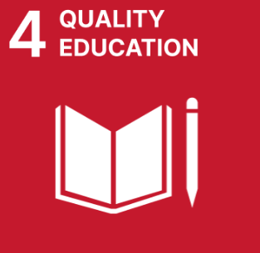  SDG 4: Ensure inclusive and equitable quality education and promote lifelong learning opportunities for all | By 2030, substantially increase the number of youth and adults with in-demand skills, including technical and vocational skills, for employment, decent work and entrepreneurship. | - Creating training programs and organizing training for the Bank's personnel;  - support professional development of employees at the expense of the Bank
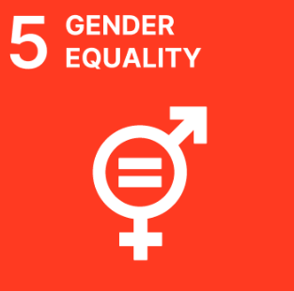  SDG 5: Ensure gender equality and empowerment of all women and girls | Ensure women's full and meaningful participation and equal opportunities for leadership at all levels of decision-making in political, economic and public life. Eliminate all forms of discrimination against all women everywhere. | - Implement initiatives aimed at supporting women;  - implementation of special women's housing programs;  - Creation of equal working conditions and career opportunities;  - ensuring equal performance appraisal and remuneration systems.
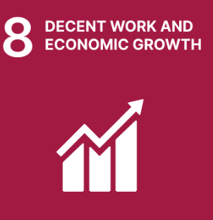  Goal 8: Promote sustained, inclusive and sustainable economic growth, full and productive employment and decent work for all | Promote sustained, inclusive and sustainable economic growth, full and productive employment and decent work for all | - Ensuring decent work for all;  - Regional development impact and multiplier effects on related industries and the economy as a whole.
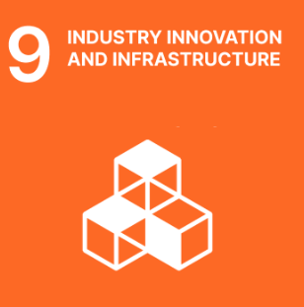  Goal 9: Build resilient infrastructure, fostering inclusive and sustainable industrialization and innovation | Significantly increase access to information and communications technologies | - Implement digital technologies;  - automation of the Bank's business processes.
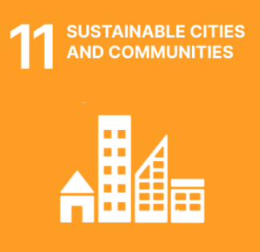  Goal 11: Make cities and human settlements open, safe, resilient and environmentally sustainable | By 2030, ensure universal access to adequate, safe and affordable housing and basic services and upgrade slums;  Strengthen efforts to protect and preserve the world's cultural and natural heritage. | - Ensure housing affordability;  - Sustain and implement sustainable cities initiatives.
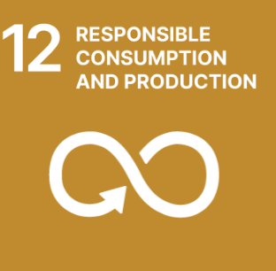  Goal 12: Ensure a shift towards sustainable consumption and production patterns | Implement the 10-Year Strategy for Action on Sustainable Consumption and Production Patterns with the participation of all countries, with developed countries taking the lead, taking into account the development and capacity of developing countries.  By 2030, achieve the sustainable development and efficient use of natural resources;  By 2030, substantially reduce waste through prevention, reduction, recycling and reuse;  Encourage companies, especially large and multinational companies, to adopt sustainable production methods and to reflect information on sustainable resource use in their reports. | - Increase the culture of energy conservation;  - reducing resource consumption (energy consumption, water consumption);  - optimizing paper-based workflow through automation of the Bank's business processes.
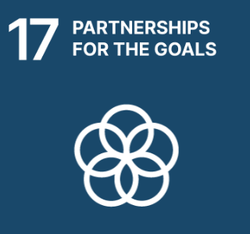  Goal 17: Strengthen the means of implementation and revitalize the Global Partnership for Sustainable Development | Adopt and implement investment promotion regimes for least developed countries | - Maintain cooperation and partnerships for sustainable development.

Chapter 4. PRIORITY AREAS FOR ACTION AND RELATED GOALS
- The Sustainable Development Strategy identifies several key areas of focus for long-term sustainability and socio-economic progress, as well as for environmental and corporate responsibility. These priorities are in line with the sustainable development goals proposed by the UN and are aimed at addressing pressing social and environmental challenges, creating favorable conditions for sustainable economic growth and improving the quality of life of the population.

Direction | Objective | Bank's contribution
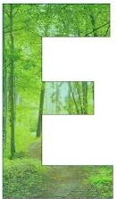  Environmental sustainability | - Development of "green" lending and support for energy-efficient projects.  - Minimizing environmental impact through environmental initiatives and raising employee awareness. | Serious attention is paid to environmental sustainability and environmental protection. As part of this, the Bank is actively developing green lending practices aimed at financing projects that contribute to improving the environmental situation, reducing the carbon footprint and supporting energy-efficient technologies. An example of such a project is the "green mortgage" program aimed at purchasing apartments in energy-efficient residential complexes built to "green standards", thus supporting the strategic initiative to promote environmentally friendly housing.  The development of green lending contributes not only to sustainable development, but also to attracting investment in projects that have a long-term positive effect on society and nature.  The Bank also takes measures to minimize its environmental impact. Introducing environmental initiatives and raising awareness among employees about the principles of sustainable development are becoming an important part of the internal corporate culture. The Bank's employees are trained in the principles of environmental responsibility and are actively involved in various environmental initiatives, such as reducing resource consumption and implementing green office practices. These measures are aimed at reducing the Bank's negative impact on nature and creating sustainable environmental standards.
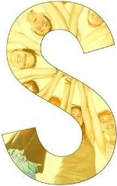  Social inclusion and housing affordability | - Providing preferential mortgage loans to socially vulnerable groups.  - Increasing the share of loans with targeted social effect in the Bank's loan portfolio. | One of the main areas of focus is improving housing affordability for socially vulnerable groups. The Bank is actively working on expanding the possibility of obtaining preferential mortgage loans for such categories of citizens as large families, low-income citizens, disabled people and other socially vulnerable groups. Provision of concessional mortgage loans contributes not only to increasing the affordability of housing, but also to improving the living conditions of the population, which is an important step in realizing social inequality and improving the quality of life.  In addition, one of the most important priorities is to increase the share of loans with targeted social effect in the Bank's loan portfolio. This includes financing projects that contribute to solving social problems, such as the construction of affordable housing, supporting programs to improve housing conditions for needy segments of the population, and providing loans for the implementation of social projects. To this end, the Bank actively develops partnerships with public and private organizations, which allows it to expand the range of available services and support social inclusion.
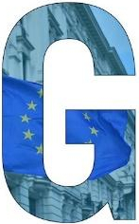  Governance and responsibility | - Implementing the principles of Governance, Ethics and Inclusion.  - Participation in national and international sustainable development initiatives, including membership in the ESG Club of Kazakhstan. | An important aspect of the Sustainable Development Strategy is the implementation of the principles of Governance, Ethics and Inclusiveness, which ensure transparency, fairness and accountability in the Bank's operations. The principles of ethical behavior and inclusiveness help to create a corporate culture focused on respect for the rights of all employees and customers, as well as on effective and fair management of the Bank. This not only increases trust in the Bank, but also contributes to a healthy and open corporate environment where the interests of all parties are valued.  As part of its corporate responsibility, the Bank actively participates in national and international sustainable development initiatives, which is confirmed by its membership in the ESG Club of Kazakhstan. Participation in such initiatives provides an opportunity to share experience with other companies and organizations promoting the principles of sustainable development, as well as to implement best practices in the field of environment, social responsibility and Governance.
- Thus, the Bank's priorities are aimed at addressing important social and environmental challenges, creating conditions for sustainable growth and social inclusion, and developing effective Governance, which contributes not only to economic growth, but also to improving the quality of life of the citizens of Kazakhstan.

Chapter 5. ESG-RISK MANAGEMENT
- Otbasy Bank carries out comprehensive management of risks related to sustainable development, focusing on High international standards and best practices in this area. Given the impact of social, environmental and corporate factors on the Bank's activities, effective risk management becomes a key element of the Sustainable Development Strategy. It allows not only minimizing possible negative consequences, but also ensuring long-term stability and successful functioning of the Bank in the conditions of changes in the external environment.

Paragraph 1: ECOLOGICAL RISKS
- The Bank considers environmental and climate risk management as an integral part of its sustainable development strategy. The Bank consistently integrates these risks into strategic and operational processes, ensuring environmental impact reduction, energy efficiency improvement and compliance with environmental responsibility principles.
- As part of the climate agenda implemented in the Bank's operations, climate risks are integrated into the overall risk management system. In 2024, the Bank, together with an international consulting company, conducted a comprehensive analysis of physical and transient climate risks and implemented climate stress tests. Based on the results of this work, a methodology for assessing climate risks was approved and is applicable on a permanent basis.
- Starting from 2023, the Bank calculates greenhouse gas emissions under Scope 1 and Scope 2 categories in accordance with national methodological recommendations. Starting in 2024, the Bank began calculating GHG emissions under Scope 3, including financed emissions associated with mortgage lending. The calculation methodology is based on international PCAF (Partnership for Carbon Accounting Financials) principles and takes into account building characteristics, construction type, geographic location and projected energy consumption.
- To reduce Otbasa's environmental risks, the bank is actively developing areas of green lending. Priority is given to projects that contribute to environmental protection, increase the energy efficiency of facilities and reduce the carbon footprint. This approach allows not only to minimize potential environmental risks, but also to form the Bank's contribution to the sustainable environmental development of the country.
- Thus, the Bank demonstrates a systematic approach to environmental and climate risk management, confirming its commitment to the principles of sustainable development and promoting ESG standards in the Republic of Kazakhstan.

Paragraph 2: SOCIAL RISKS
- As part of its Sustainable Development Strategy, the Bank recognizes the importance of effective social risk management, especially in the context of labor relations and support for socially vulnerable segments of the population. The Bank strives to ensure fair and inclusive working conditions for its employees, and actively engages in social initiatives aimed at improving the quality of life of citizens, especially those facing economic and social hardship.
- Otbasy Bank JSC adheres to the principles of equality and non-discrimination in labor relations. In accordance with the laws of the Republic of Kazakhstan and internal regulations, the Bank:
- provides equal opportunities for all employees, regardless of gender, age, race, religion or other characteristics.
- applies objective criteria in selection and promotion of personnel based on professional knowledge and competencies.
- creates conditions for career growth and professional development of employees through training and professional development programs.
- ensures protection of employees' rights, including the establishment of an ombudsman institution and the Conciliation Commission for consideration of individual labor disputes.
- Otbasy Bank JSC actively implements social programs aimed at supporting socially vulnerable groups of population. As part of its activities, the Bank:
- provides mortgage loans on preferential terms for large families, disabled persons, orphans, employees of budget organizations and other categories of citizens facing difficulties in purchasing housing.
- implements programs to subsidize rental housing, making housing affordable for low-income citizens.
- implements initiatives to use pension savings to improve housing conditions and pay for medical treatment, in accordance with the Social Code of the Republic of Kazakhstan.
- cooperates with local akimats to implement regional programs aimed at improving the housing conditions of citizens in various regions of the country.
- The Bank actively assesses and manages social risks related to labor relations and support for socially vulnerable segments of the population, where:
- conducts regular assessments of the impact of its social programs on target populations.
- ensures transparency and accountability in the implementation of social initiatives by publishing relevant reports and evaluation results.
- Otbasi Bank reaffirms its commitment to the principles of social responsibility and sustainable development by actively working to improve the working conditions of its employees and support socially vulnerable populations. The Bank will continue to develop and implement new initiatives aimed at solving social problems and improving the quality of life of citizens of the Republic of Kazakhstan.

Paragraph 3. CORPORATE RISKS
- Otbasy Bank JSC considers effective Governance of corporate risks as a fundamental element of business sustainability, stakeholder confidence and achievement of strategic goals.
- To mitigate corporate risks, the Bank has a well-developed Governance System, including:
- The Board of Directors, which provides strategic guidance, supervises executive bodies, and monitors compliance with the principles of sustainable development. Its tasks include general control over the implementation of the sustainable development strategy, a set of environmental and social risk management policies, compliance with the requirements of the Risk Management System, as well as timely and reliable disclosure of information in the field of sustainable development;
- Audit Committee, considers issues on establishing an effective system of control over financial and economic activities of the Bank (including the completeness and accuracy of financial statements), compliance with the laws of the Republic of Kazakhstan, internal documents, as well as to prepare recommendations to the Board of Directors of the Bank on the development of priority areas of activity (development), and the functioning of an adequate Risk Management System of the Bank;
- Strategic Planning and Corporate Development Committee, considers issues related to the development of priority areas of activity (development), strategic goals (development strategy), corporate development issues, including issues related to the development of measures to improve the efficiency of the Bank's activities in the Average and long-term perspective, its profitable operations and sustainable development;
- Risk and Internal Control Committee, prepares recommendations to the Board of Directors on monitoring the reliability and efficiency of the internal control and risk management system, compliance with the legislation of the Republic of Kazakhstan, internal documents, as well as for preparation of recommendations to the Board of Directors on the development of priority areas of activity (development), and the functioning of an adequate risk management system in the Bank, improvement and strengthening of the risk management system, as well as considers issues of sustainable development of the Bank.
- The Human Resources, Remuneration and Social Affairs Committee considers issues related to HR policy, the system of appointments and remuneration, as well as performance evaluation of the members of the Board of Directors of the Bank, members of the Management Board of the Bank, succession planning for the Chairman and members of the Management Board, and performance evaluation of the Corporate Secretary.
- Otbasy Bank has approved and implemented internal documents governing corporate risk management:
- Governance Code;
- Code of Business Ethics;
- Anti-corruption policy;
- Policy on Settlement of Corporate Conflicts and Conflict of Interest;
- Sustainable Development Policy.
- The Bank ensures transparency of its activities through:
- disclosure of information on management bodies and key decisions;
- publication of the annual report and sustainable development report, including sections on ESG and corporate sustainability;
- publication of financial statements certified by an independent external audit;
- participation in ESG ratings and initiatives aimed at increasing stakeholder confidence.
- The Bank performs regular assessment of corporate risks and updates the risk register and map. Internal control mechanisms are adapted to changing internal and external conditions. ESG and risk management training is also provided to employees and members of the management bodies.
- Otbasi Bank adheres to High standards of corporate governance aimed at identifying, mitigating and managing corporate risks. This enables the Bank to ensure stability, long-term sustainability, meet the expectations of regulators and investors, and enhance public and partner confidence.

Chapter 6. ESG-KPD (KEY PERFORMANCE INDICATORS)
- The Bank uses the following key performance indicators to monitor and evaluate the effectiveness of its sustainability strategy:
№ | Key performance indicator | Unit of measurement | Calculation methodology | Target value for 2030 | Data source  data
E - in the field of environment
1 | Reduction of greenhouse gas emissions from Bank operations (coverage 1, 2,3 ) | % | (GHG emission level for 2030 / GHG emission level for 2024 .) *100 - 100 | minus 7% of the 2024 baseline. | Bank's Management Reporting, Report on Implementation of the Sustainability Action Plan
2 | Volume of "green" mortgages | billion tenge | Total amount of loans issued under the "green" mortgage program from 2023 | ≥ 70 billion tenge | Management reporting of the Bank, Report on implementation of the Sustainable Development Action Plan
S - in the social sphere
3 | Volume of "social" mortgages (social programs) | % | Share of social mortgages (in %) = (Volume of social mortgages in loan portfolio / Total loan portfolio) *100 | Increase in the share of social mortgages to 43% of the total loan portfolio. | Management reporting of the Bank, Report on the Implementation of the Sustainable Development Action Plan
4 | Bond issue for implementation of the Nauryz social housing program. | KZT billion | Total amount of social bonds placed for the purpose of sustainable financing | ≥ KZT 200 bln  annually | Management reporting of the Bank, Report on implementation of the Sustainability Action Plan
G - in the sphere of management
5 | Maintaining ESG rating on international scale | - | Level not lower than "3/60" with positive dynamics |  | Management reporting of the Bank, Report on the implementation of the Sustainability Action Plan

excluding financed emissions under Category 15
The base year was changed from 2023 to 2024 due to changes in the approach to calculating greenhouse gas emissions under Scope 2, as well as in connection with the development of a methodological approach to estimating emissions under Scope 3.
At the end of 2024, the share of social mortgages of the total loan portfolio is 39%.
ESG rating of "3" with a total score of "55" is assigned in 2024

